**Consumer Behavior: Individual Project – Soul Shine**

Hannah Johnson

Stevenson University

MKT 311

Dr. Victoria Miller

December 11, 2022

Table of Contents

I. Executive Summary 2

II. Situation Analysis 4

III. SWOT Analysis 7

a. Strengths 7

b. Weaknesses 7

c. Opportunities 7

d. Threats 8

IV. Target Market 8

a. Consumer Profile 9

b. Decision/Consumption Process 10

c. Internal Influences 11

i. Learning and Information Processing 11

ii. Perception 12

iii. Psychographics/Lifestyle 12

d. External Influences 13

i. Family 13

ii. Culture 13

iii. Subculture 14

iv. Reference Groups 14

V. Original Project or Business Concept 15

VI. Marketing Program 16

a. Product/Service 16

b. Place/Distribution 16

c. Price 16

d. Promotion (Integrated Marketing Communication) 17

VII: Conclusion 19

References 19

# I. Executive Summary

Wellness and positivity both physically and mentally are very important in today’s world a culture, especially for women. According to The National Organization for Women, “One study reports that at age thirteen, 53% of American girls are “unhappy with their bodies.” This grows to 78% by the time girls reach seventeen.” (NOW, 2022). Soul Shine is a company that is a “safe space” for women, where they are educated about self-care, wellness and positivity, all whilst participating in relaxing amenities such as exercise classes, art/creative classes and being able to get fresh juices and smoothies from the in-house juice bar. Soul Shine also has a clothing boutique inside of the location where merchandise such as t-shirts and hats are sold and 10% of each sale is donated towards The Body Positivity Organization.

Self-care and positivity are both very important things as a woman. It is important for people to be able to take care of themselves first, before putting others in front. Social media in today’s world is very influential on women and how they compare themselves to others. According to The Nursing Times, “evidence is growing, particularly in adolescent mental health, of an association between greater social media use and higher depressive and anxiety scores, poor sleep, low self-esteem and body image concerns (Kelly et al, 2018; Royal Society for Public Health 2017)”. It is easy for people to fall down a hole and get stuck in the mindset that they should be like the others.

Soul Shine’s goal is to develop a community of women with similar lifestyles and values who want to learn more about wellness and positivity and how it can positively impact their lives. Customers will be able to be educated through exercise classes and art classes. The purchases made from the boutique will benefit an organization that has to deal with women’s body positivity. When customers begin their journey at Soul Shine, they will begin to learn more about themselves and will be able to network with others who are going through similar things.

The reason for Soul Shine becoming relevant now would be because of the growth of the issue of body image in the world right now. The issue is becoming more and more prominent and is affecting the mental health of people. Soul Shine will educate and spread awareness about the importance of wellness, self-care and positivity.

# II. Situation Analysis

The 5 C Analysis will be used to analyze the brand Soul Shine. The 5 C’s are company, collaborators, customers, competitors and context.

**C-Company**

Products:

* Juice Bar
* Workout classes
* Art/Creative classes
* Soul Shine clothing

Competitive advantages: Soul Shine is a one of a kind brand because there are no other companies that incorporate all of the amenities that Soul Shine has within one location. The location is in NYC which is good because it will bring in a lot of customers. Any woman of any age is invited, and it is a “safe-space”.

Goals:

* To promote positivity and wellness
* To educate women about self-care and how important it is
* To support The Body Positivity Organization

**C-Collaborators**

Partners and investors: A partner of Soul Shine is The Body Positivity Organization. 10% of the purchase of a clothing item from Soul Shine’s boutique will be donated to the organization.

Suppliers and distributors: Suppliers of Soul Shine would include the company that makes the branded clothing, the smoothie/juice packs used at the juice bar, the workout equipment, and art materials.

Service providers: Providers of service would include the staff at the juice bar, the customer service staff and the employees who educate the customers.

**C-Customers**

Target audiences: The target audience of Soul Shine is women of all ages who want to learn more about themselves through positivity and wellness.

Customer motivations/behaviors: What motivates customers to come to Soul Shine may be different for everyone. For example, someone could have an eye-opening experience in their life and want to change their life for the better. Another example may be women being inspired by others to try something new and good for themselves. Customers who come to Soul Shine are open to trying new things and are adventurous.

Communication channels: The brand will communicate to its customers through social media platforms (TikTok, Instagram, Facebook, Twitter and Snapchat). Weekly emails will also be sent out to customers, which inform them on the classes that are provided that week and any other important information. Soul Shine has a website where important information can be found as well for non-customers if they are not on the email list.

Customer perceptions: Customers view Soul Shine as a relaxing outlet to explore themselves, while working on positivity and wellness. The customers have these perceptions because the brand showcases what it wants the customer to feel and think. Soul Shine markets themselves as a “safe-space” where trying new things are encouraged and the atmosphere is fun and positive.

**C-Competitors:**

Established/emerging competitors: Established competitors of Soul Shine would include gyms, spas, wellness retreats, yoga studios, juice bars and art studios. These would be competitors because Soul Shine only has one location whereas gyms and spas have multiple locations so they can reach many customers.

Competitor strengths/weaknesses: Strengths of the competitors would include having more than one location of their business, having cheaper costs, women and men both being allowed to use the facilities, and the convenience of getting to the locations. Weaknesses of the competitors would be that they are not supporting non-profit organizations, they may not be considered a “safe space” by women, and that all of the amenities that Soul Shine has these businesses do not have.

**C-Climate:**

Laws/regulations: A regulation that Soul Shine has is that the business is geared towards women only and not men. Also, younger kids are not permitted, women 18+ are allowed to use the facility.

# III. SWOT Analysis

## a. Strengths

Soul Shine is a one of a kind brand that offers a variety of products and services all revolved around positivity and wellness. The New York City location offers yoga/pilates courses, an art studio where painting and other creative classes are offered, an in-house juice bar and a clothing store. A Strength of the brand would be that no other brand/company has all of these amenities in one convenient location like Soul Shine does. Another strength of Soul Shine would be that the brand focuses on a relevant topic in today’s society, which allows for more people to be attracted and want to learn more about the company. Soul Shine is located in a very popular metropolitan area, New York City which will bring in lots of customers. Lastly, customers will want to shop more when they realize that a portion of the proceeds goes to The Body Positivity Organization.

## b. Weaknesses

Along with strengths of a brand or company there are always weaknesses as well that we have to keep in mind. A weakness of Soul Shine would be that there is only one location at the moment which is located in New York City. People who live in other states will not get to experience Soul Shine, except for the brand’s online store which carries select pieces of clothing. Another weakness of the brand would be people choosing to go to an alternative place like a gym or a spa for their wellness and positivity fix instead of going to Soul Shine. A final weakness may be the prices of the items being sold such as the juices, exercise classes, art classes and clothing. The prices may be higher than the usual gym membership or tee shirt because a portion of the proceeds are donated to The Body Positivity Organization.

## c. Opportunities

There are several opportunities for Soul Shine as a company. An opportunity of the company is to spread positivity around and to create a community that has similar wellness goals. Another opportunity would be if the New York City location is in popular demand, more locations could be built across the U.S in order to expand the Soul Shine brand. A final possible opportunity of the brand would be the ability to network with other body positivity and wellness non-profit organizations, and to expand from just supporting one organization to many.

## d. Threats

There could be threats that are considered to the Soul Shine brand. Examples could be spas, gyms, art studios and stand-alone juice bars. Due to Soul Shine having only one location, the threat to the brand would be potential customers using other amenities. Another threat could be yoga classes being held by other local studios which would draw attraction away from Soul Shine. All of these may be threats to the brand, but due to Soul Shine’s uniqueness and modern take on wellness and positivity, the brand is constantly staying up to date with the latest trends and catering to what the customers want.

# IV. Target Market

The target market for Soul Shine is women of all ages who want to immerse themselves in a positive, inclusive, and wellness-based environment. Focusing on the brand’s consumer motivation would be utilitarian based due to consumers coming into Soul Shine hoping to gain functional or practical benefits. The benefits could be achieved by attending a wellness yoga class or instructional canvas painting. When consumers walk into Soul Shine, they will be greeted by bright colors, fun modern art, the smell of citrus coming from the juice bar, and friendly employees, and that is how the consumer perception of the brand will be, bright, fun, and bold. The self-concept or how the consumer of Soul Shine would view themselves would be someone interested in learning more about themselves through body positivity and wellness. Consumer socialization applies to the consumer of Soul Shine because they may be familiar with organizations focused on women’s body positivity and wellness, which may gear them toward being interested in the brand.

What motivates the women to come to Soul Shine and participate in the brand’s events is their wanting to focus on their wellness and health, boost their confidence and connect with a positive and uplifting community of women. This is similar to what motivates me because I always try to better myself mentally and physically. I try to do this by participating in activities that I enjoy, such as the ones provided at Soul Shine. There are varying perceptions about women’s wellness and positivity, and it can be a controversial subject to talk about. Outsiders may dislike what Soul Shine’s mission is; for example, the events and clothing at the location may be too expensive for one’s taste or not everyone’s style. Soul Shine participates in corporate social responsibility by sharing a portion of its revenue with The Body Positive Organization. Younger people will be socialized about Soul Shine through social media such as Instagram, Snapchat, and TikTok. Soul Shine will also have a YouTube channel that will include fun, inspirational videos!

## a. Consumer Profile

Target Consumer Profile:

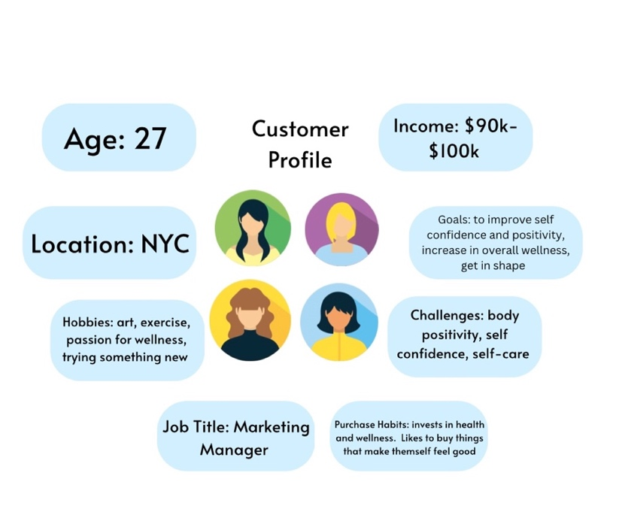

## b. Decision/Consumption Process

The stages of the consumer decision process relate to Soul Shine’s target market through Need Recognition, Information Search, Evaluation of Alternatives, Purchase/Decision, and the Post Purchase Evaluation. As stated previously, the target market of Soul Shine is women of all ages who want to learn about the topic of women’s wellness and need wellness, self-care, and positivity in their lives. Women will develop a sense of Need Recognition for the brand when they need a change in their lives regarding wellness and positivity Women may also feel a need for a safe space and a sense of community which Soul Shine offers. This sense of need for self- care, wellness and positivity could be spiked by an event, for example, someone feeling down on themselves recently or going they are going through a tough time and wanting/needing a positive change.

The second stage Information Search comes into play, where the women would gain information about Soul Shine. Soul Shine has various social media platforms, including TikTok, Instagram, Facebook, and YouTube. Throughout these platforms’ information is shared, such as special events that are going on that week (date and time), Instructional exercise videos (yoga), clothing sales, and more. Information regarding Soul Shine is also provided on the organization’s website. Website details will be similar to what is posted on social media (calendar of events, location, hours, the background of Soul Shine, etc.).

Soul Shine is a one-of-a-kind, unique organization. There are no direct competitors or alternatives that exactly replicate what the organization offers. Going to a spa or a Pilates class may be similar, but that is just a portion of what Soul Shine offers. Consumers may evaluate the price of the events/activities, the location of Soul Shine (close or far away, in a popular area), the friendliness of the staff, etc. The target consumer will decide to support Soul Shine by deciding if wellness, self-care, and positivity are something they want to invest in. If the topic of women’s health is important to the consumer, that will ultimately make their decision. Key determinants that would be used to evaluate an experience at Soul Shine would be customer service satisfaction, the consumer’s opinion on the activity/event, and the consumer’s likeliness to return.

The value of Soul Shine is created by the consumers and what they get out of their experience; if they hold a high value of the organization, they will return. Soul Shine is more hedonic because the organization ensures consumers are happy with their experience and have a pleasant time. The satisfaction of the consumers is provided by meeting their expectations because if they enjoy their time and their expectations are met or exceeded at Soul Shine, they will come back and tell others about their good experience.

## c. Internal Influences

### i. Learning and Information Processing

Information processing theory: According to Simply Psychology, “information processing in humans resembles that in computers” (2008).

Encoding, storage and retrieval are the three steps of the memory process.

Encoding: an example of encoding related to Soul Shine would be remembering the last time someone did self-care for themselves.

Storage: (sensory memory, short-term memory, long-term memory)

An example of sensory memory would be the senses that take place when walking into Soul Shine for the first time. Colors, sounds and smells are all a part of sensory memory. An example of short-term memory would be the Soul Shine website and what parts of it look like. An example of long-term memory would be the memory of Soul Shine as a whole and the main business goal and what the brand does.

Retrieval: An example of retrieval would be recognizing/remembering what the Soul Shine website looks like when it is pulled up on the computer again.

### ii. Perception

Perception defined in the textbook is “the process by which stimuli are selected, organized and interpreted” (Solomon, n.d). Perception is related to Soul Shine because it is how both customers and outsiders view the brand. How customers perceive Soul Shine may be different than how outsiders perceive it. For example, customers may love the brand because they have already formed a relationship about it. Outsiders may not know enough about the brand or they may consider it overpriced, because they do not know about all of the amenities offered.

### iii. Psychographics/Lifestyle

According to the textbook, psychographics is referred to as involving the uses of “psychological, sociological and anthropological factors … to determine how the market is segmented by the prosperity of groups within the market- and their reasons- to make a particular decision about a product, person, ideology, or otherwise hold an attitude or use a medium” (Solomon, n.d). A general lifestyle segmentation would apply to customers of Soul Shine. According to the textbook the general lifestyle segmentation study “places a large sample of respondents into homogenous groups based on the similarities of their overall preferences” (Solomon, n.d). The lifestyle segmentation that customers of Soul Shine are involved in would be people who want a healthy change in their life, are open to trying something new, want to better themselves physically and mentally and who want to support a good cause.

### d. External Influences

### i. Family

Family can influence the customers of Soul Shine as well. Family members may like the brand already and convince other family members to go with them to a yoga class or painting event. A family member may discuss their journey with wellness and educate other family members on why it is important to take care of your body. This will then attract attention to the topic, and research will be done on gyms/wellness centers, where Soul Shine comes into play. A family member may struggle with body positivity and influence others to support the cause by buying a tee shirt from the Soul Shine clothing section; a portion of the proceeds would be donated to The Body Positivity Organization.

### ii. Culture

According to our textbook, acculturation is “the process of learning the value system and behaviors of another culture” (Solomon, n.d.). When new customers experience Soul Shine for the first time, they learn what the brand is about and what makes the brand special from the people around them at the store. For example, the instructors who lead the yoga classes or the customer service employees who work the desk will educate customers about the brand and why they chose Soul Shine as their destination for relaxation. As customers continue their journey at Soul Shine, the more times they visit, they will become accustomed to the culture of the brand.

#### a. Enculturation

Enculturation, in the textbook, is “the process of learning the beliefs and behaviors endorsed by one’s culture. Enculturation and the brand Soul Shine can go hand in hand because of the values of the brand, which are wellness and positivity. The importance of positivity and physical/mental wellness can be enculturated and instilled into people from the beginning, and it could come from grandparents, parents, etc. The enculturation process starts at a young age as people are familiarized with a culture.

### iii. Subculture

According to our textbook, a subculture is “a group whose members share beliefs and common experiences that set them apart from other members of a culture” (Solomon, n.d.). A subculture culture of Soul Shine would-be customers who use the brand to exercise and better their physical health. This subculture is set apart from the culture because the customers are specifically interested in exercising. In contrast, other subcultures of the brand may use Soul Shine for the art classes they provide or the juice bar they have. The values of the exercise subculture of Soul Shine would be wanting to stay in shape or wanting/needing a change for their body. The exercise subculture would have different values than the art subculture about why they go to Soul Shine. Still, when the subcultures come together to make up the brand culture, the customers are all there for positivity and wellness.

### iv. Reference Groups

A reference group defined in the textbook is “an actual or imaginary individual or group that has a significant effect on the individual’s evaluations, aspirations, or behavior” (Solomon, n.d.). Possible reference groups of Soul Shine would be the employees who work for the brand or other enthusiasts of wellness and positivity. The employees of Soul Shine can help steer people in the right direction by assisting customers in participating in the activities the brand provides that help with positivity and wellness. The frequent customers or enthusiasts of Soul Shine may influence the newer customers by helping them out and telling them events to attend, recommendations at the juice bar, or what time they like to participate in the yoga classes. Peer influence can also be connected to this.

# V. Original Project or Business Concept

The organization Soul Shine is an original business that I am creating for this project. Soul Shine is a business that focuses on spreading positivity. Soul Shine educates women on the importance of self-care and mental health through the weekly events that the brand holds to get women of any age involved. Weekly events are held at Soul Shine’s Studio which is located in New York City. Events consist of candle making, yoga/pilates and canvas painting, throughout these events’ awareness of mental health, wellness and self-positivity are spread. Soul Shine also has its very own in-house juice bar and clothing section where positive quotes/sayings are branded onto the clothing.

The target market of Soul Shine is women of all ages who want to spread positivity and want to get into self-care and wellness, while also building confidence. Soul Shine can be escape for women who need a refresh and peace, the staff is nonjudgmental and are very energetic and happy people. The Soul Shine Studio is very bright and cheerful, with the pastel bright colored walls and furniture. After all, the goal of the brand is to spread awareness about the importance of self-care, wellness and positivity. A portion of the revenue earned by the sales of Soul Shine’s clothing will be donated to The Body Positivity Organization.

# VI. Marketing Program

## a. Product/Service

Soul Shine offers many products and services.

* Juice bar
* Yoga/Pilates studio with workout equipment
* Art/creative center
* Soul Shine Boutique
* Sweatshirts
* Pants
* Accessories
* T-shirts
* Shorts

## b. Place/Distribution

According to Super Heuristics, “Place in marketing mix, in layman terms, means distribution. This is because the place of production isn’t the same as the place of consumption” (2020). Soul Shine is located in New York City. There is only one location at the moment, but there are hopes of expanding. The location is placed in a perfect area of the city where locals can walk from their apartments. Soul Shine is in a busy area which will attract lots of customers and potential customers interests.

## c. Price

*All-inclusive membership*: Access to workout studio, creative center, juice bar, and 15% discount on boutique purchases - $200 a month

*Day pass:* access to workout studio, creative center, juice bar, and clothing boutique all for 1 day. - $35

*Tranquility Package:* access to creative center and juice bar - $50 a month

*Fit and Fun Package:* access to workout studio and juice bar -$75 a month

Boutique Pricing:

* Sweatshirts - $60
* Pants - $40
* Accessories (Socks, hair ties, hats) -$5-$25
* T-shirts -$30
* Shorts -$25

***All boutique purchases donate 10% of each sale to The Body Positivity Organization***

Juice Bar Pricing:

6oz - $5

12oz- $10

16oz $15

## d. Promotion (Integrated Marketing Communication)

Logo:

This logo will be used in all marketing materials for Soul Shine. The color scheme of the brand is seen throughout the logo. This logo will also serve as the profile picture for Soul Shine’s social media platforms.

* Fliers will also be created and put up around local apartment complexes, cafes and local hot spots to Soul Shine

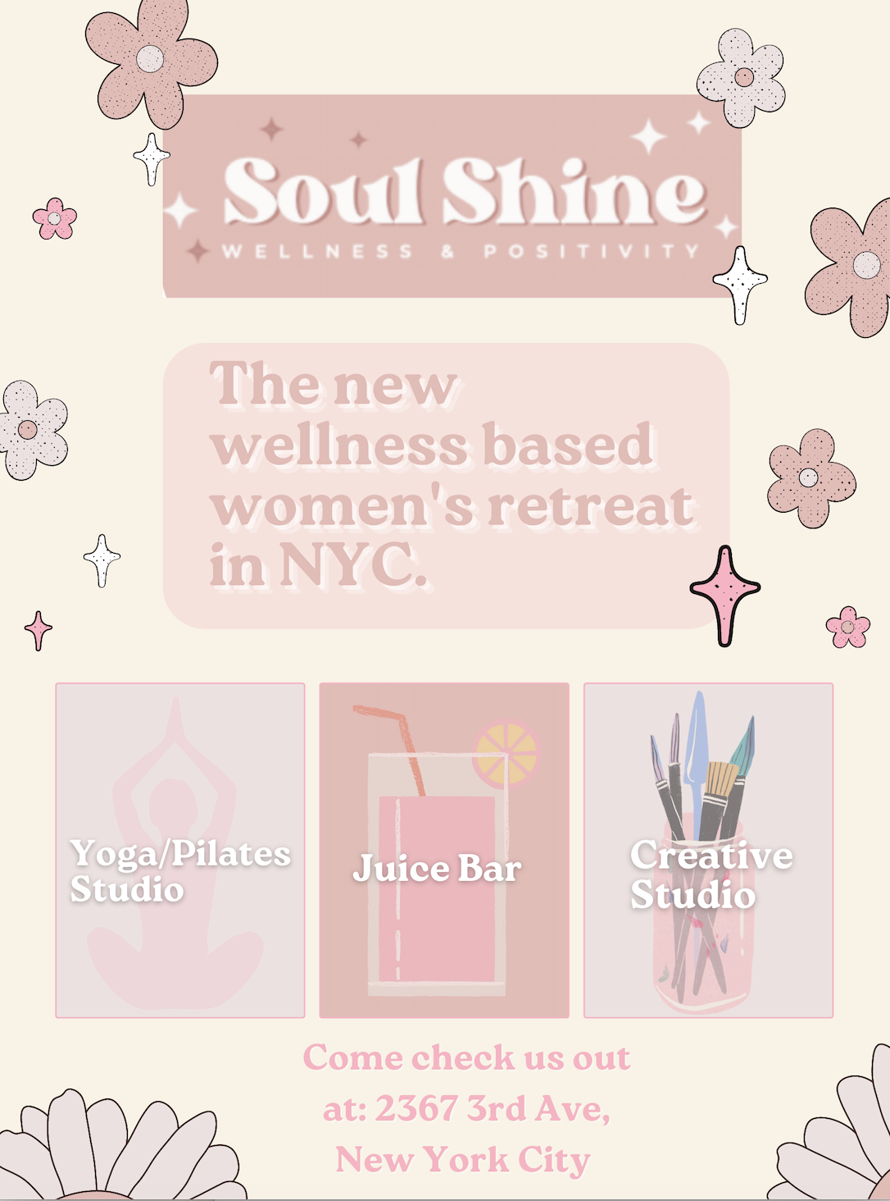

Social Media: Soul Shine will also be promoted on various Social Media platforms such as Instagram, Twitter, Facebook, Snapchat and TikTok. Social media is very popular today, especially in NYC where technology keeps getting bigger. The main way the brand will be promoted will be through social media.

# VII: Conclusion

Soul Shine is a one of a kind experience for women that focuses on wellness and positivity. Customers will be welcomed into a “safe space” and will be able to have the opportunity to connect with others with the same lifestyle. Soul Shine is a for profit brand, but also donates 10% of all boutique purchases to The Body Positivity Organization. Amenities such as a juice bar, creative studio, fitness studio and boutique are all incorporated into Soul Shine’s New York City location. Soul Shine is marketed and promoted on various social media platforms in order to attract women of many backgrounds. The Soul Shine company hopes to expand into other areas of the country where more women can enjoy the community.

# 

# References

Contributor, N. T. (2020, February 24). *How use of social media and social comparison affect mental health*. Nursing Times. Retrieved December 4, 2022, from https://www.nursingtimes.net/news/mental-health/how-use-of-social-media-and-social-comparison-affect-mental-health-24-02-2020/

*Love your body: National organization for women*. National Organization for Women -. (n.d.). Retrieved December 4, 2022, from https://now.org/now-foundation/love-your-body/

Mcleod, S. (1970, January 1). *Information processing theory*. Information Processing | Simply Psychology. Retrieved December 4, 2022, from https://www.simplypsychology.org/information-processing.html

Solomon, M. R. (n.d.). *Consumer Behavior, 13/e*. Retrieved from <https://platform.virdocs.com/r/s/0/doc/618731/sp/270136550/mi/782805437?cfi=%2F4%2F2%5BP7001015468000000000000000001FF3%5D%2F10%5BP7001015468000000000000000001FFC%5D%2F2%5BP7001015468000000000000000001FFD%5D%2F20%5BP700101546800000000000000000203B%5D%2C%2F1%3A0%2C%2F1%3A0>

Vishwal, S. (2022, February 17). *Understanding place in marketing mix*. Super Heuristics. Retrieved December 4, 2022, from https://www.superheuristics.com/place-in-marketing-mix/